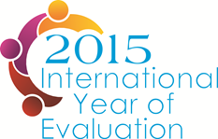
EvalYear
Ensuring 2015, the International Year for Evaluation, will make a difference in strengthening an enabling environment for evaluation to improve people’s lives through better policy making
_________________________
- The Innovation challenge in a snapshot
EvalPartners, the global partnership to strengthen national evaluation capacities, will declare 2015 as International Year for Evaluation (EvalYear). EvalYear will be a catalyst for important conversations and thinking, at international, regional, national, and sub-national level, on the role of evaluation in good governance for equitable and sustainable human development. EvalYear will position evaluation in the policy arena, by raising awareness of the importance of embedding evaluation systems in the development and implementation of international, national and subnational development goals and strategies.
- EvalYear, a Global Initiative of Coordinated Local Action
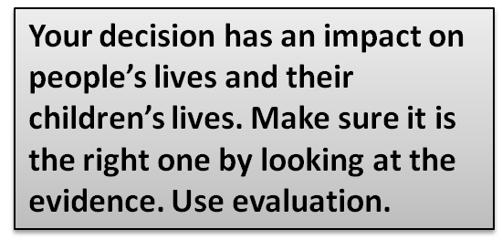
Governments, international partners and civil society need to know how policies and programs shape the lives of people today and in future generations. Given this, EvalPartners is facilitating a global dialogue among regional and national evaluation actors, evaluation offices of International Organizations, including UN agencies and the World Bank’s IEG, OECD/DAC and developing countries, private foundations and other key stakeholders. The aim of the dialogue is to designate 2015 as the International Year of Evaluation (EvalYear) in order to advocate and promote evaluation and evidence-based policy making at international, regional, national and local levels.

EvalYear will be a unique opportunity to focus specifically on Evaluation in all its diversity. It will act as a catalyst for important conversations and thinking, at international, regional, national, and sub-national level, on the role of monitoring and evaluation in good governance for equitable and sustainable human development. Evaluation can enable leaders and civil society to develop and support better policies, implement them more effectively, safeguard the lives of people, and promote well-being for all. Evaluation can enable leaders to consider social, political, technical, financial factors, and make sure they are on the right path. Evaluation can help leaders report to their constituents honestly about the impact of their decisions, and listen to feedback from every group. However, if evaluation is to play these roles more dedicated effort, systems change, capacity building, and resources are required.

The intention of EvalYear is to position evaluation in the policy arena, by raising awareness of the importance of embedding monitoring and evaluation systems in the development and implementation of the forthcoming Sustainable Development Goals, and all other critical local contextualized goals, at the international and national levels. EvalYear is about taking mutual responsibility for policies and social action through greater understanding, transparency, and constructive dialogue.

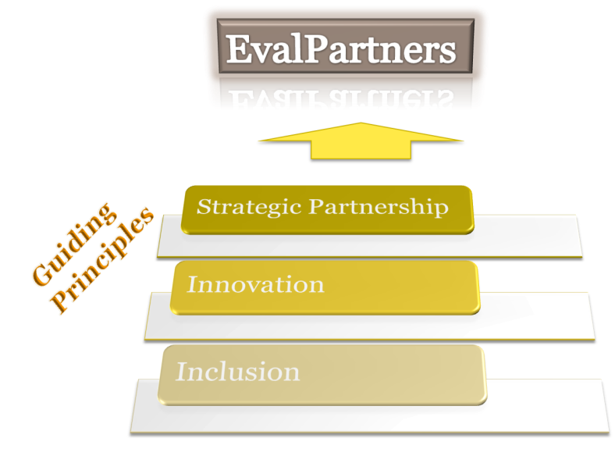
In the spirit of the EvalPartners Guiding Principles, EvalYear will bring together diverse stakeholders into a movement designed to mobilize the energies and enhance the synergy of existing and new monitoring and evaluation initiatives at international and national levels.

EvalYear features inclusion where everyone has a role to play: civil society, governments, international partners, academia, and individuals. For example, EvalYear will help to shape opinion and influence decision making through Voluntary Organizations for Professional Evaluation (VOPE)’s conferences and UN evaluation-related meetings that will keep the spotlight on policy coherence for equitable, and gender responsive sustainable development and good governance in the international and national arenas.

EvalYear invites innovation at many levels: it could mean an innovative approach to the focus for the Challenge, methods of engagement and capacity building, peer-to-peer exchanges, use of technology for communications and scale up, and involvement of new partners.

EvalYear will bring together a strategic partnership of committed individuals and organizations around the world for coordinated action to promote evaluation as a catalytic intervention for better human development.
2015 is the year when the Millennium Development Goals (MDGs) will be replaced by a new set of internationally agreed goals, most likely to be called Sustainable Development Goals (SDG). While the MDGs drove a global vision on human development and facilitated its implementation and monitoring, a comprehensive evaluation of what has been achieved has not been carried out so far. In part this is because the country level building blocks for such a review were not available. It is now widely acknowledged that national development policies and programs should be informed by evidence generated by country-led monitoring and evaluation systems, rather than donor-led ones, while ensuring policy coherence at regional and global level.
But other trends are also important. Citizen demands for evidence and greater accountability from governments are growing in movements across the globe. There is a bottom up swell for greater accountability that is leading to new innovations to strengthen and hold policy makers accountable. This bottom up response (and its tools of participatory evaluations, social audits, citizen report cards, etc.) is coming together with other international level approaches including the SDG and other processes to create very interesting spaces and possibilities. Citizen’s growing engagement in monitoring and evaluation, their demands, and their push for transparency, accountability, change and justice, also justify making 2015 the year of evaluation.

EvalPartners is an innovative partnership designed to enhance the capacities of Civil Society Organizations (CSO) to influence policy makers, public opinion and other key stakeholders so that public policies are based on evidence, and incorporate considerations of equity and effectiveness. The objective of the Initiative is to enhance the capacities of CSOs to engage in a strategic and meaningful manner in national evaluation processes, contributing to improved country-led evaluation systems and policies that are equity-focused and gender equality responsive.
In line with the Quadrennial Comprehensive Policy Review (QCPR) resolution of the UN General Assembly, and the Paris/Accra/Busan Declarations

